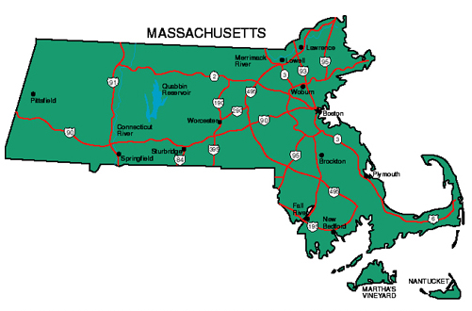

Massachusetts Transportation Resources

- Mass Mobility
Initiative to increase mobility for seniors, people with disabilities, veterans, low-income commuters, and others who lack transportation access in Massachusetts.
www.mass.gov/orgs/massmobility
- Massachusetts Department of Transportation www.massdot.state.ma.us
- Massachusetts public and private transit systems
www.apta.com/research-technical-resources/public-transportation-links/massachusetts
- Massachusetts Regional Transit Authorities
http://matransit.com
- Massachusetts Human Service Transportation Office - www.mass.gov/hst
- Massachusetts Ride Match – www.massridematch.org
- MassCommute
Massachusetts Transportation Management Associations - private, non-profit association of businesses that join together to improve commuting options. www.masscommute.com

September 2019

